Name: Ramy Gamal Mohamed Abdelmageed

B.N: 1
Section:14
Date: 5/june/2021
Topic: Artificial intelligence (AI)

Application Brief…

*Artificial intelligence (AI) is intelligence demonstrated by machines, unlike the natural intelligence displayed by humans and animals, which involves consciousness and emotionality. The distinction between the former and the latter categories is often revealed by the acronym chosen. 'Strong' AI is usually labelled as artificial general intelligence (AGI) while attempts to emulate 'natural' intelligence have been called artificial biological intelligence (ABI). Leading AI textbooks define the field as the study of "intelligent agents"
**I have chosen this topic because Artificial intelligence opens a world of opportunities. At a basic level, you'll better understand the systems and tools that you interact with on a daily basis. ... In the field of artificial intelligence, the possibilities are truly endless.

Sreen-Shots
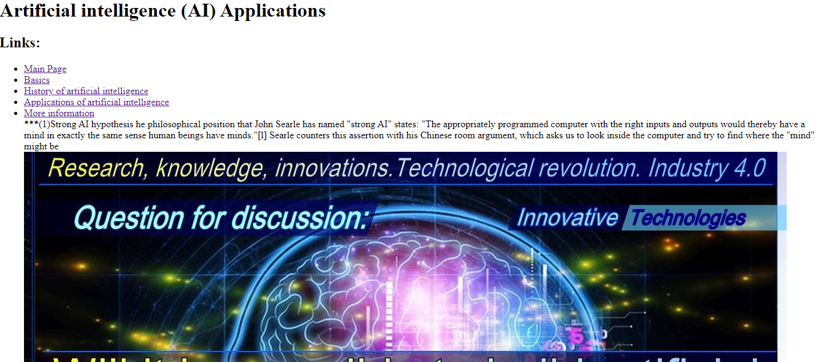

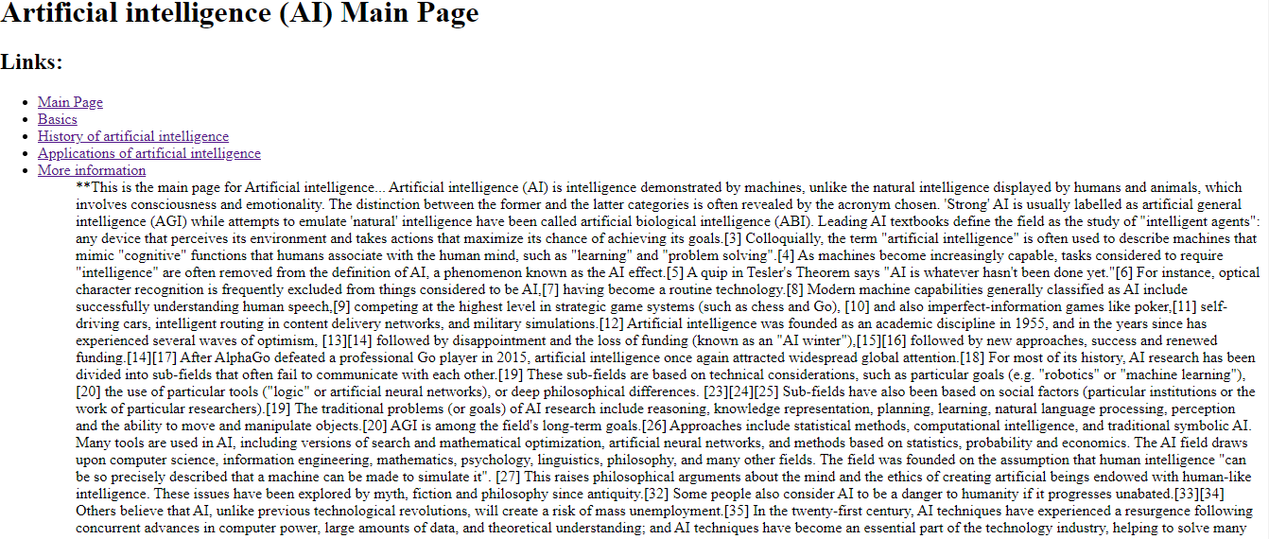

Source-Code

